**Overview**

As a trainee in project management, I was fortunate to have the opportunity to work on a project for a period of one month. The project involved the development of a new chatbot in website for a small startup company in the tech industry.

Throughout the project, I was responsible for assisting the project manager with various tasks, including scheduling meetings, tracking project progress, and updating project documentation. I also had the opportunity to work closely with the development team, helping to ensure that the project was progressing according to plan and that any issues or obstacles were quickly addressed.

One of the most valuable aspects of the project management experience was the opportunity to see firsthand how a project is managed from start to finish. I was able to observe how the project manager communicated with stakeholders, set project goals and milestones, and tracked progress using various project management tools and techniques.

In addition to my day-to-day responsibilities, I was also given the opportunity to contribute to the project in a more substantial way. Specifically, I was tasked with developing a project charter, which involved the detailed plan of the project.

This experience allowed me to develop and apply my project management skills in a real-world setting. I learned how to effectively communicate with team members and stakeholders, how to manage project scope and timeline, and how to identify and mitigate project risks.

Overall, my project management experience as a trainee was an invaluable opportunity to gain hands-on experience and develop the skills needed to succeed as a project manager. I have attached the project carter below which I worked on during my traineeship.

**Project charter**

Project Name: Taboola Connect

Project duration: 15/05/2022 – 16/06/2022

**Project Team**

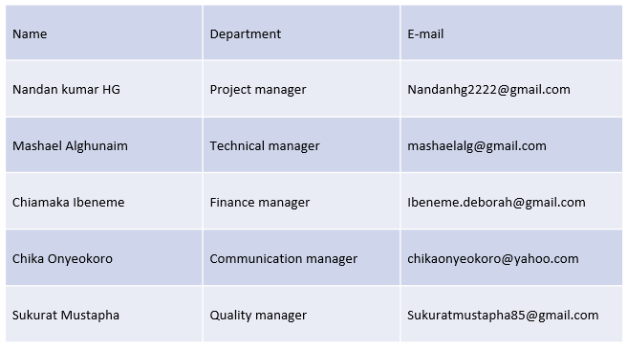

**Project purpose**

The purpose of this project is to improve the way Taboola deals with customers' issues.

In the past when customer issues arise at Taboola, customers would contact the Account Manager to resolve the issue.

If the issue was technical, the Account Manager would contact Taboola’s Support on behalf of the customer to resolve the issue.

This was not an optimal system to deal with customers' issues.

To improve this process, the Professional Services team suggests the introduction of a direct communication service with Taboola Support. This will form part of the Professional Service’s customer-centric approach.

The new service will allow customers to open a case directly with the Taboola Support team via the website and communicate directly with the engineer or respective party handling their case.

**Objectives**

Reducing time and efforts wasted for Taboola’s support team.

Organize managing the issues by directing each of them to the concerned department to respond.

Creating a direct communication channel with customers.

Making the ability to open issue tickets available 24/7.

Collecting issues data and analyzing it to use it for developing the company’s services and customer support system.

**Deliverables**

Online automated bot or AI integrated into Taboola’s website and social media platform.

Training workshops for employees on how to respond after the process of the Bot ends.

**Project Milestones**

The project is to be concluded in four weeks, observing the following structure:

Week 1

Project planning

Market research (customers surveys) & analyzing previous issues database.

Week 2

Execution, and monitoring

Week 3

Testing and trial version

Project refining and final touches

Week 4

Project conclusion and submission for approval

evaluating the project and creating reports

**Potential risk**

**Constraints**

Customers knowing about the new service and adapting to it.

Marketing team is to be able to analyze the customer’s behavior and help create the questions journey of the bot.

**Communication plan**

**Stakeholder Register**

**Organizational Breakdown structure (OBS)**

**RACI**

